Boyds Civic Association
October 17, 2019 Meeting Minutes
(Revised)

Call to Order: President Hammet Hough called the Boyds Civic Association (BCA) to order on October 17, 2019. Thirty-one were present.

Minutes July 18, 2019 (Maggie Bartlett): were approved.

Treasurer’s Report (Elena Shuvalov): $13,029.76 (as of 10/17/2019) was approved.

UPDATES
• Boyds Historical Society (Miriam Schoenbaum):
- Flea Market (October) profit was $631.80
- Archives: Photo Identification Day Saturday, January 18 2:00-4:00 pm at the Boyds Negro School.

• Survey Monkey about the intersection of Rtes. 121 and 117 (Miriam Schoenbaum): 69 responses so far.

• Railroad Bridge/Pedestrian Crossing (SHA Andre Futrell’s office Claudine Meyers): There will be no concrete sidewalk or pedestrian light because the CSX bridge over Clarksburg Rd. is too narrow for both a pedestrian walkway and two-way vehicular traffic. A BCA member asked if a push-button signal could be installed to at least temporarily stop traffic from Barnesville Rd., Clarksburg Rd. and Clopper Rd. while pedestrians cross through intersection. Another member asked if the signal cabinet could be moved to allow pedestrians to walk/ride directly off the trail and through the intersection. Another member asked why not use the existing pedestrian crossing under the railroad tracks. It was determined that that crossing is not ADA compliant.

• Anderson Property/MARC Plan (Pam): The 30% Design Plan includes a space-saving one-way circular loop for cars parking, parking spaces for Boyds Country Store patrons, a dedicated bus exit, a shelter for riders waiting for buses, and additional lighting. Another public meeting will take place on Tuesday, October 22 7:00 pm at Ronald McNair Elementary School. MTA will coordinate with CSX Railroad Transportation on future plans. As for timing: the proposed budget will go to Montgomery County Council in January; County Council will vote in March; if funded, the design will be finalized in about a year. MTA is working with Maryland Historic Trust and with Park and Planning for design input at the 65%, 90%, and 100% design plans.

NEW BUSINESS

• Peachtree and Barnesville Roads Intersection (Addi Davis): After an accident at the intersection, Addi suggested that the BCA request a stop sign to improve safety, especially with the Barnesville School at that intersection.
MOTION: “The Boyds Civic Association requests that MCDOT make the intersection of Barnesville Road and Peachtree Road safer with a consideration for a four-way stop, flashing light, or speed cameras, etc.” Motion was passed unanimously.

• White Ground Road (Marta Aiken): WGR is very bumpy and is not on the list for road improvements. It was suggested that Marta call 3-1-1, Montgomery County’s Customer Service Center for non-emergency government information and services.

• School Re-districting (Gordon Taylor): The Board of Education will vote in November about the new school-district boundaries at a meeting at Seneca Valley High School.

Next BCA meeting: January 16, 2020 at 7:30 pm.

Motion to adjourn was passed.

Minutes respectfully submitted by Maggie Bartlett, Secretary, Boyds Civic Association

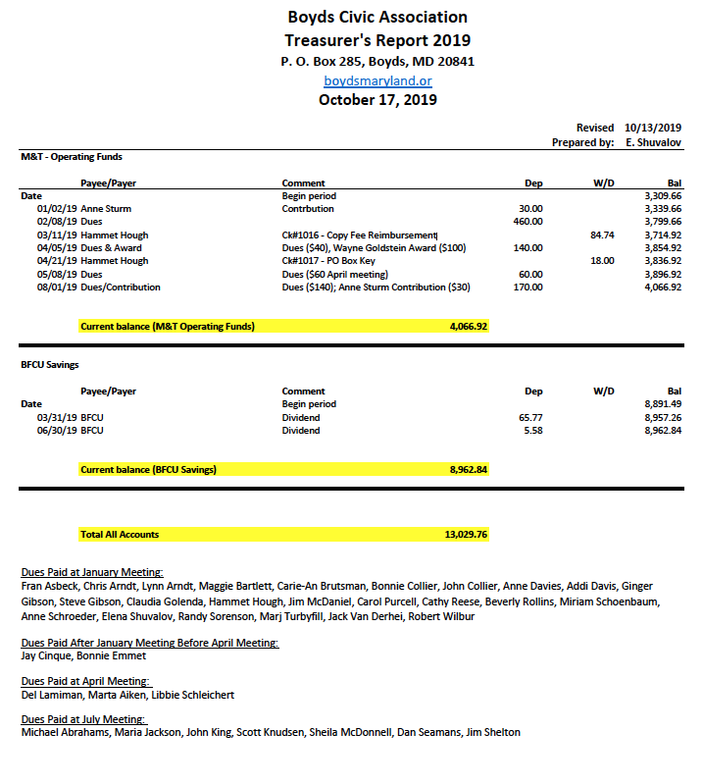

Treasurer’s Report respectfully submitted by Elena Shuvalov, Treasurer, Boyds Civic Association

