**DRAFT**

**Boyds Civic Association**

**April 20, 2023 Meeting Minutes (REVISED)**

**Call to Order:** BCA President Dan Seamans called the Boyds Civic Association (BCA) to order on April 20, 2023 at

7:34 pm. Fifteen (15) people were present.

**Minutes** (Maggie Bartlett)**:** Minutes from the January 19, 2022 meeting were approved with amendments.

**Treasurer’s Report** (Elena Shuvalov): Treasurer’s report was presented and approved. Funds total $13,283.63.

**ANNOUNCEMENTS**

**Audit Committee (**Claudia Golenda/Randy Sorenson): Committee met via Zoom and found no discrepancies. Audit is now complete.

**MOTION:** Motion to approve the Audit Committee report was approved unanimously.

**OLD BUSINESS**

**∙ B&O Metropolitan Branch Railroad Sesquicentennial (150-Year Celebration):** MARC will run an excursion train to arrive at Boyds at 12:28 pm on Monday, May 29. Dan will install the three banners around the Boyds train station area. A potluck picnic will start on May 29, 11:30 am – 2:00 pm. Parking is available at the Boyds Presbyterian Church parking lot.

**∙ Boyds Historical Society:**

* Open Houses: February (two), April 16, May 21
* Next meeting: Tuesday May 16 at 7:00 pm
* Flea Market (Germantown): May 6. Bring donations to the Boyds Negro School on April 30.
* Edward U. Taylor was designated as an historical building by the County Council.
* BHS is trying to identify photos from Arthur Virts photo collection.

**∙ Boyds Transit Center** (Dan Seamans): MCDOT’s 95% design plan handout was available. The Hoyles Mill building will be preserved with the cost estimated to renovate at $2 million; septic (tank portion) will also be renovated. The barn brick and block buildings will be torn down along with other miscellaneous structures. The underpass needs repairs. Please send your comments to Dan Seamans.

**∙ Bucklodge Industrial Plan:** Preliminary plan was amended to have five buildings (four will be two-story and one will be a large one story). We are hoping for vegetation screening. Plans will be sent to Harry St. Ours to post on BCA website.

**NEW BUSINESS**

**∙ Possible CSA** (Daniella Ochoa): Daniella lives on Whites Ferry Road and hopes to promote CSAs in the area.

**∙ Native Plant Sale**: will be held at the Black Hill Regional Park.

**∙ Boyds Presbyterian Church** (Marie Alnutt): “Adult Getting Together” meetings will be held on the first Saturday of the month 9 am - 12 pm. Bring your own beverage.

**∙ Dump Truck Traffic on Barnesville Road**: County is addressing the issue of a Boyds resident selling top soil.

**∙ Trains with Chemical Cargoes** (Kasey Kaseman): This issue needs to be brought to the attention of our state representatives and interstate transportation to make sure inspections are performed in order to protect communities (like Boyds) along railroad tracks.

**∙ Clarksburg Town Center** (Gordon Taylor): Located at the northeast corner of Stringtown Rd. and Rt. 355, there will be development of 250,000 sq. ft. Weiss Market will be an anchor store with 56,000 sq. ft. with a remainder of 40,000 sq. ft. yet to be determined. There will also be townhouses and multifamily homes.

**∙ Little Free Library** (Chris Arndt): The Boyds Country Store has offered to host a new Little Free Library.

**MOTION**: The Boyds Civic Association will fund $250-450 to pay for the actual structure after further research of costs.

**Next BCA meeting:** July 20, 2023 at 7:30 pm.

**MOTION to adjourn was passed unanimously at 9:05 pm.**

*Minutes respectfully submitted by Maggie Bartlett, Secretary, Boyds Civic Association.*

|  |  |  |  |  |  |  |  |
| --- | --- | --- | --- | --- | --- | --- | --- |
|  |  |  |  |  |  |  |  |
|  |  |  |  |  |  |  |  |
|  |  |  |  |  |  |  |  |

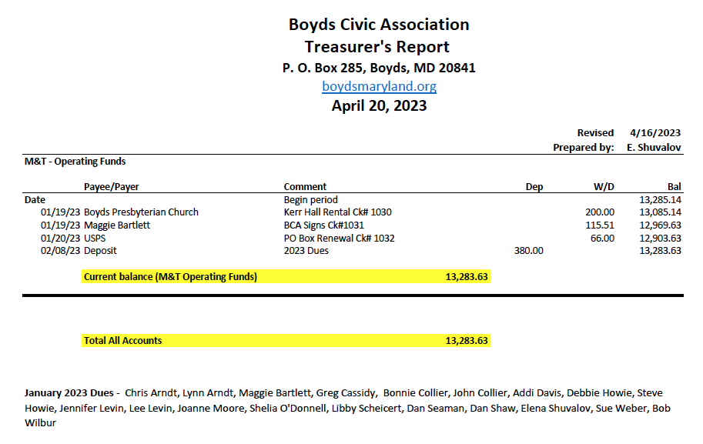

*Treasurer’s Report respectfully submitted by Elena Shuvalov, Treasurer, Boyds Civic Association.*